*ACH forms must be submitted 48-72 hours prior to the date you’d like it authorized*
Tenant Name: ______________________________________________
Property Address: ___________________________________________

Recurring Charge – You authorize regularly scheduled charges to your Bank Account. You will be charged the amount indicated below each rental period.
I __________________________ authorize Rodney Long Properties/Long Property Management to charge my Bank account below for $___________ beginning on ________ (Date) every month. End Date: _____________

Bank Account Information
Account Type: Checking Savings

Name On Account - ________________________________________

Bank Name - _____________________________________________

Account number (#) -_______________________________________

Routing number (#) -_______________________________________

I guarantee and warrant that I am an authorized user of this bank account and that I am legally authorized to enter into this billing agreement with the Merchant(Rodney Long Properties/Long Property Management). I certify that I will not dispute this scheduled transaction(s) with my bank so long as the transaction correspond to the terms indicated in this authorized form.

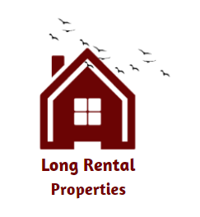
Authorized Signature _______________________________________ Date ______

